**Name = Talal Khan**

**Roll Number = DT-22043**

# OS LAB 01

**Question 1: Execute all the commands discussed in this lab.**

**Solution:**

* Date:



* Cal:

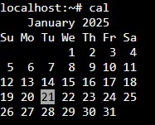

* Echo:



* Ls:



* Whoami:



* Uptime:



* Uname:



**Course title = Operating Systems**

**Course code = CT-353**

**Name = Talal Khan Roll Number = DT-22043** • Hostname:



* Bc:

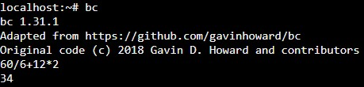

* Cat:

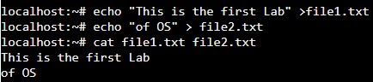

* Rm:

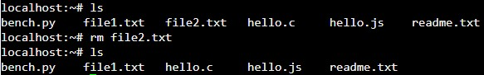

* Wc:

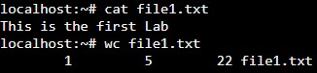

**Course title = Operating Systems**

**Course code = CT-353**